**SQL TABLES**

There are two tables that are used in the software for many purposes.

These Tables are created by using “Microsoft SQL Server Management Studio 2008 R2”.

Database Name: Usb_mgmt

Tables:

1. password:

Use of this table is to Save user Password, Retrieval old password. Update new password.

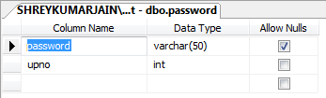

1. user_settings:

The main use of this table is to save User Settings so that it can be used and saved till the next restart of the Application.

